**Group Project Report**

**COVER PAGE**

|  |
| --- |
| **Group Number**  7 |
| **Project Title**  Charity Run For Irish Wildlife Trust |
| **Group Members**  **Name Role (if any assigned) & Text reviewed**  Scott Kelly Project Manager & Accounts;  “Leadership and Self-Deception”, the  Arbringer Institute  Naoise Synnott Documentation – “Getting things Done”,  David Allen  Sian Cregan Documentation – “Thinking Fast and  Slow”, Daniel Kahneman  Seamus Kilian Security & Volunteers – “The no  Asshole rule”, Robert I Sutton  Cathal Killeen Advertisements – “Mind-set”, Carol S  Dweck  Cathal McClean Advertisements – “Emotional  Intelligence”, Daniel Goleman  Szabolcs Lakatos Health & Safety – “The Psychology of  Persuasion: Influence”, Robert B  Cialdini  Kevin Nally Sponsorships – “Thinking Fast and  Slow”, Daniel Kahneman |

**Group Project Report**

**Page 2**

**Overall Meeting Attendance Summary**

|  |
| --- |
| **Group Number**  7 |
| Total number of meetings: 8 |
| **Group Members**  **Name Number of meetings attended**  Kevin Nally 6  Naoise Synnott 7  Cathal Killeen 7  Szabolcs Lakatos 6  Seamus Kilian 7  Cathal McClean 7  Sian Cregan 7  Scott Kelly 7 |

**Project Scenario**

|  |  |
| --- | --- |
| **Title** | **Description** |
| Project Name | “Team 10K” |
| Project Manager | Scott Kelly |
| Project Sponsor(s) | Various local charities to sponsor spot prizes |

The key criteria for this project are:

* **Scope:** This project aims to organize a 10k charity run with all proceeds going to the Irish Wildlife Trust.
* **Start Date: 3rd February 2015**
* **Finish Date: 7th April 2015**

**Background:** The project our group has chosen is the organization of a charity 10km run in the Phoenix Park, Dublin with all proceeds going to the Irish Wildlife Trust (IWT). IWT is a non-governmental organization that was initially founded in 1979 as a charitable party for the conservation on Ireland’s wildlife and habitats.

Our project will be designed so that each individual member of our working team will have a sufficient number of tasks to complete.

**Breakdown of tasks:**

|  |  |  |  |  |  |
| --- | --- | --- | --- | --- | --- |
| **Advertisement** | **Health and Safety** | **Documentation** | **Sponsorship** | **Security/Volunteers** | **Accounting** |
| Website | Insurance | Permits | Source sponsors | Hi-visibility for volunteers | Money/ Float |
| Facebook page | First aid/red cross | Registration-online only | Organize prizes/spot prizes | Barriers, cones etc. | Registration fee |
| Flyers/posters | Warm up/cool down station | Contact running websites/ athletic clubs | Photographers | Volunteers for stopping traffic | Gantt charts |
| Local papers/ newsletters | Water and snacks (during and after race) | Donation to IWT | Advertisement of sponsors on the day | Contact Gardaí for on the day security | Expenses |
| Roadside banners/ posters | Toilet facilities | Entry fee | PA system for the day | Sign in on day | Large cheque for IWT charity |
| Radio advertisement and video | Clean up volunteers /equipment | Route-design map | Entertainment | Racing numbers etc |  |

**Project Reports and Resources**

In this section, the reports of each of the team members will be presented. Each member will describe the research and work they did to help the project to succeed in the end. Some of the work is hypothetical, because we did not actually perform a 10k run for charity, but rather planned out the tasks that we would do if it were real.

This is organised in such a way that all written reports appear first, and all resources referenced in the reports, like the Gantt chart and accounts, will be placed afterwards.

**Contents:**

1. Accounts (Scott Kelly)……………………….……………………………………………
2. Health & Safety (Szabolcs Lakatos)………………………………………………..
3. Advertisement 1 (Cathal McClean)...……………………………………………..
4. Advertisement 2 (Cathal Killeen)……………………………........................
5. Security & Volunteers (Seamus Kilian)…………………………………………..
6. Sponsorship (Kevin Nally)………………………………....………………………….
7. Documentation (Sian Cregan & Naoise Synnott)…………………………..
8. Gantt chart……………………………………………………………………………………
9. Accounts……………………………………………………………………………………….

Accounts/Project Manager Report

I (Scott Kelly) volunteered to be the project manager for the project, and also for the accounts side of the project. As the lead, I set out the schedule, and with the help of Sian Cregan, set out the roles that needed to be done. We then assigned roles to our team members and continued with our work.

Firstly I set out the time for each of our tasks to be completed. I then built on top of this with hypothetical tasks to be done, since we wouldn’t actually be organizing the run in real life. With this information I made the first edition of our Gantt chart. After showing it to the group and they suggested how to improve it, Naoise Synnott volunteered to apply the upgrades as she had better Gantt chart skills than I did. (See attached Gantt chart)

Primarily during the project I tried to help the team members with any queries that they had, and help lead them in the right way so that they created good work to help the project, and keep it on time. I helped each person write the minutes when it was their turn to chair the meeting.

I also helped Cathal McClean find stock footage for the video on the royalty free footage site www.videoblocks.com. The “happy rock” music track, which was the second track in the video, came from [www.bensound.com](http://www.bensound.com). I then helped Cathal M to create an idea on how the video would play out, and then using his editing skills he created the video.

In relation to the accounts, I gathered most of the figures from the other members of the team, for example Szabolcs Lakatos helped me find a suitable figure for the insurance needed. After we all decided on the price per person as stated in the technicalities/documentation report, I was able to approximate the number of people that would come to our event, and work out the revenue we would take in from the event, including sponsorships too.

With the expenses figures gathered from the team members, I then finished the account sheet and calculated that we could hypothetically make up to over 20,000 euro for the Irish Wildlife Trust. (See attached accounts)

I then organized the hard copy of the project to hand up, compiling everyone’s work.

Health and Safety

**Insurance:**

We were advised to cover our event by a liability insurance as it is required by law while obtaining the permits. Even though a charity run might seem like a relatively tame outing, we must be prepared for any unfortunate incidents.

Most frequent troubles we have to face as organisers of charity runs are encompassed by medical problems on-site. Second potential problem is damage caused by the participants. While we’re unlikely to recruit vandals into the event, stomped grass in the park or discarded litter can result in a demand for financial coverage from city council.

Our insurance policy provided by walk/run event insurance specialist, K&K Insurance Group, will remove our liability in the case of medical trouble or property damage resulting from our event.

Insurance details:

* Maximum number of participants is 6000
* Maximum number of event days is 1 days or less
* Total course distance cannot exceed 10 miles

Coverage:

* Bodily Injury and Property Damage
* Personal and Advertising Injury
* Damage to Premises Rented to Us
* Medical Expense (other than participants)
* Professional Liability
* Legal Liability to Participants

Cost: Euro - 1500

**First Aid:**

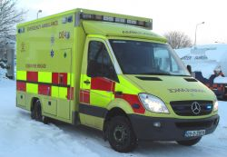Preventive actions were taken to make our charity run as safe as possible.

Medical students from UCD College of Health Science volunteered to provide entry level first-aid, water and snacks at each checkpoints if needed. Also, volunteer students which had a certificate in first aid issued by organisations such as the Red Cross helped.

Mr Pat Fleming, Chief Fire Officer from Dublin Fire brigade was able to provide us one of their emergency ambulances with two advanced paramedics for the duration of the event. Their position will be at checkpoint 10. The major advantage of having trained personnel on site is that we are covered for any serious injuries might happen during the event.

Cost: Euro - 500

**Toilet Facilities:**

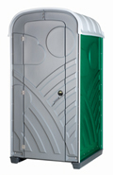

Portable toilets will be needed for a race of this size, and will provide participants with their basic human rights and allow and easy clean-up of the run track.

They are provided by **Tufloo Toilet Rental Limited, Dublin. 10 units will be located at Checkpoint 1, 2-2 units at each Checkpoints 2-4-6-8 and further 10 units at Checkpoint 10.**

**Total cost for the 28 unit: Euro - 1400**

**Food & Water:**

Bottled water and basic nutrition (banana, energy drink etc) will be provided to all participants on the day. While this is complimentary to thank everyone partaking in the race, it is also a safety precaution.

It will help prevent people from becoming too dehydrated, or becoming too weak to continue the race, and in turn, will help reduce the possibility of someone fainting throughout the race.

Total cost: Euro – 2050

# Advertisement

# Advertising

In an event like a charity run, one of the most important aspects is to spread awareness. The public needs to know that this event is happening, and details like where and when. The ‘product’ of a charity project like this is not actually the run itself, but the revenue generated as a result of the run, be it public recognition or financial revenue.

Cathal Killian and Cathal McClean were both tasked with the management of this section of the project. Their goal was to produce a number of different ways in which the organizers of the event could communicate with the general public in such a way that the event would gain momentum and spread further through word of mouth.

## Newspaper Article

This article was created to mimic a news headline the day after the event. In most cases, events like the charity run are covered by local newspapers, so it seemed apt to include this as part of the project.

It may seem counterintuitive to say that a newspaper article covering the event that already happened is key to the success of the event, it is very true in the case of charity events. The finance generated by the event is only a part of the intention of the run in the first place. The charity also wants to spread awareness of their goal, how it will aid the general public, and generate a general buzz about their organization. This will ultimately lead to more donations and a large turnout to their next upcoming event, which will in turn generate more revenue.

It was for this reason that McClean decided to focus the content of the article towards three things: the success of the run, the fun that everyone had, and the ways it will help the local community. Even though the event already occurred, it doesn’t stop the charity from trying to gain more donations, so the newspaper article is also a form of advertisement.

## Video Advertisement

The group decided to make a promotional-style video to convince the public to attend the event. Because the group had very little experience in filming videos, let alone quality equipment, the decision was made to instead download stock footage and music to create the video. McClean was nominated to edit the video, as he had some experience in using Sony Vegas, the video editing software.

The stock footage itself was found by Scott Kelly, who forwarded the videos to Cathal to use in the project. Some difficulties arose when Cathal’s laptop broke down, and the unfinished video was lost. Luckily, the raw footage was backed up online, and the half-finished video was recovered a few days later, allowing the editing process to continue as normal on an alternative computer with only minimal time delay.

# Advertisement 2

I (Cathal Killeen) was responsible for the marketing and promotion of the event along with Cathal McClean. The marketing and promotion involved designing and distributing posters and flyers, radio and newspaper advertisements, designing posters to recruit volunteers, managing the social media presence of the event and setting up and managing the event website.

## Website

I set up a website for the event using a Wordpress theme. The websites domain name is [www.phoenixrun.ie](http://www.phoenixrun.ie) which was registered on hostingireland.ie. The hosting for the website was also purchased from HostingIreland. A package deal of both the domain and hosting cost €39.99 for the year. This was the total cost of the website as the wordpress theme was free and I managed the content and upkeep of the website. Users could enter their email on the website to join the mailing list for the e-newsletter which was sent out regularly to keep users informed and excited about the event. The website was a great investment as it drew in lots of traffic and lots of users registered online on the website.

Total costs - €39.99 + maintenance

## Facebook page

We set up a Facebook page to promote the event. The page was updated regularly with photos and status updates to keep people informed and excited about the event. Some of the posts were sponsored - we paid Facebook to have the posts displayed on targeted users’ newsfeeds to promote the event. In total we spent €275 on these sponsored posts which drew in hundreds of likes for the Facebook page. Users from around Dublin and across Ireland were targeted. We also targeted people who had ‘liked’ pages relating to running, and other marathon and 10k events. After the event, photos taken by the photographer were uploaded to the page.

Total costs - €275

## Posters & Flyers

I was responsible for the design of the posters for the event. I designed several versions of the poster for the event and got feedback from the team on each iteration of the design. The poster includes a silhouette of the Wellington Monument and a silhouette of runners in front of it. The dominant colour of the poster is green which reflects the cause of the event which is the Irish Wildlife Trust. The green also of course represents the nature in the Phoenix Park.

I also designed a separate version of the poster which was used to recruit volunteers for the event. This poster has the same graphics but different content.

The posters were printed in different sizes by justprint.ie. The printing firm kindly offered us a discounted price on all of the prints seeing as the event was for a charitable cause. We included their name in small print at the bottom of all of the posters and flyers. In total we printed 500 large posters, 5000 flyers, and 200 volunteer posters.

The posters were placed in various locations throughout Dublin and surrounding areas. Posters were displayed on noticeboards in gyms, sports centres, workplaces, schools, shopping centres, universities and colleges and other public places. Some posters were also displayed on lampposts, especially on popular running and jogging routes. The flyers were posted to people’s houses by some of our volunteers. Volunteer recruitment posters were displayed mainly in schools and sports clubs.

A digital copy of the poster was distributed by email and of course through the Facebook page.

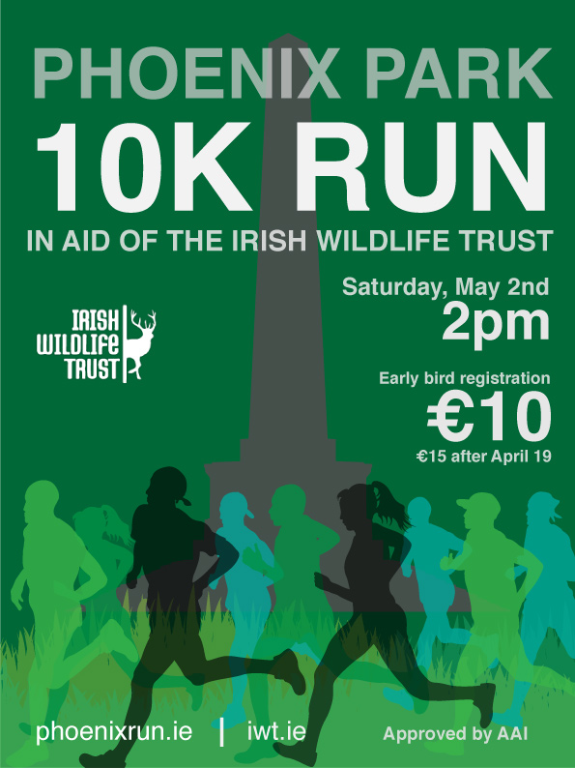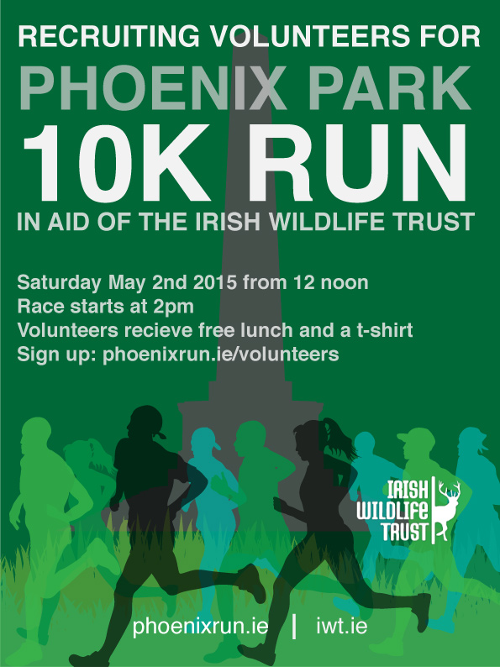

Total cost for posters and flyers - €500

## Newspaper Advertisements

The same image as the posters and flyers was displayed as an ad in newspapers. The ad was sent to several local and national newspapers. The event was advertised in the Dublin People, the Gazette group of newspapers and the Irish Times and Sunday Times.

Total cost for newspaper ads - €850

## Radio Ad

A 30 second radio ad was written and recorded to promote the race. We got in touch with TodayFM and they kindly allowed us to record the ad in their studio for free. The ad was aired on several radio stations including TodayFM, RTE 2FM and SPIN1038. The following is the text of the ad:

*Ready, set, go!*

*Are you ready for the Irish Wildlife Trust’s 10k run this May Bank Holiday weekend?*

*Join us in the Phoenix Park on May 2nd and run amongst the nature and wildlife.*

*Whether you’re a serious runner or a casual jogger, you’re guaranteed a fantastic day out in a beautiful setting, and all for a great cause.*

*Prizes will be presented on the day for the fastest times in different categories.*

*So, what are you waiting for?! Register online at* [*www.phoenixrun.ie*](http://www.phoenixrun.ie) *before April 19th to get a discounted early bird fee.*

*Help to promote and preserve Ireland’s beautiful and diverse wildlife.*

*Has the wildlife chosen you yet?*

Total cost of radio advertisements - €750

**Security and Volunteers**

***Informing the Gardaí***

The Gardaí where informed about the marathon four months in advance to ensure the marathon doesn’t clash with any other event. This involved forwarding on details such as the route of the marathon and an approximate number of attendants.

A security review was undertaken by the Gardaí to estimate the number of officers required to be present on the day. By knowing the marathon route far in advance, Gardaí were able to inform the public of the existing road blockages on the day. Road blockages fall under the category of ‘special policing’ and were arranged as a contract and included in the budget.

**Volunteers**

Volunteers where gathered from a number of backgrounds, some family members and friends of the organizers kindly volunteered to do there bit.

The transition year coordinator of Blackrock College was contacted and said that a group of 15 students were willing to participate on the day.

Several members of the IWT also came forward to volunteer. From the above three sources a total of 50 volunteers where found, the remaining 50 where found by seeking for volunteers through the events page on Facebook.

The volunteers will be used to carry out the following duties:

* **Checkpoints**- approximately every two kilometres, a checkpoint will be installed along the route supplying the participants with water and energy bars. 8 volunteers will occupy each checkpoint.
* **Sign in desks** – 10 sign in desks for registration will be installed on the day for people who didn’t use the option to register online, participants will also be supplied with a t-shirt and race number at this point.
* **Start/Finish Supervisors** – Ensure that everything at the start and finish line is in order allowing the marathon to run smoothly.
* **Publicity Distribution** – Hanging up posters and hand out leaflets on days coming up to event.
* Orientation/information - help participants find their way around and answer queries.
* **Lost children** – Gather and take care of lost children
* **Marshalls** – Help Gardaí to block roads and tail the marathon runners to ensure nobody gets left behind or needs medical assistants.
* **Other –** backup for duties requiring a larger than expected work force.

|  |  |
| --- | --- |
| **Duties** | **Number of Volunteers** |
| Checkpoints (4) | 24 |
| Sign in desks | 10 |
| Start/ Finish supervisors | 8 |
| Publicity distributors | 4 |
| Orientation/Information | 25 |
| Lost Children | 5 |
| Marshalls | 16 |
| Other | 8 |

A meeting was held at the Burlington hotel a week before the event in which the volunteers where briefed on their task and supplied with a t-shirt, high-vis jacket and a leaflet outlining a detailed description of their duty.

32 of the selected 100 volunteers came forward to help set up the event (install barriers, toilets, signing etc.) as well as tidying it up afterwards.

**Event equipment and resources**

The primary resources are that were to be organized are

* High visibility jackets
* Gaffer tape, cable ties
* Red/white hazard tape and bin bags
* Portable toilets
* Tables/chairs
* Barriers
* Water, Energy drinks, fruit and energy bars
* T-shirts and race numbers

**High Visibility jackets**

All Volunteers where to be fitted out with a high-vis jacket to be easily identified by participants, on average high-vis jackets are sold for 4 euro each. Considering that 100 high-vis jackets where required this was regarded as too expensive. The best option was to order a batch free high-vis jackets available on the RSA website. The 16 marshals had to stand out more than most volunteers and therefore their high-vis jackets where purchased and ‘Marshal’ was printed on the back.

*Total Price - €64*

**Gaffer tape, cable ties, red/white hazard tape and bin bags.**

These utensils were purchase at a hardware store (Halfords) and will be used to remove and secure things that may otherwise interfere with the participants.

*Total Price - €80*

**Tables, Chairs and Barriers**

Hireall.ie is the leading event hire specialist in Ireland and supplied tables and chairs for the sign in dock and checkpoints as well as the barriers to block off roads and certain areas, A total of 30 tables and chairs and 40 barriers where hired for the day.

*Total Price - €410*

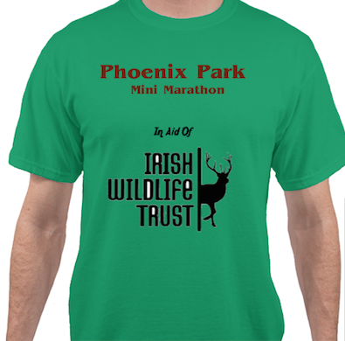**T-shirts and race numbers**

Since a total of 5000 participants are expected to attend the event, to be safe 5500 race numbers are designed and printed along with 5000 t-shirts.

The race numbers were printed by justprint.ie for a reasonable price while the t-shirts where ordered in from an American firm named Alliedshirts. From the 5000 ordered t-shirts, 1000 where size small, 2000 medium, 1000 large and 1000 extra-large. The t-shirts arrived 2 weeks before the event date and where distributed to the participants during the registration process.

*Total Price – €6000*

**Preparation**

30 volunteers gathered the evening before the event to prepare everything necessary for the day. The barriers where installed such that they separate participants and spectators around at start and finish lines, along the rest of the route, red and white hazard tape was used to do this job. The Tables and chairs for the checkpoints and registration docks where put in place and direction signs where hung up along the route.

To prevent theft, the food, drink, high-vis jackets and t-shirts where stored overnight in a lorry that was onsite.

All volunteers gathered at the site the next morning 5 hours before the marathon commenced to do final preparations including installing bins, distributing refreshments at checkpoints etc.

**Overview**

*Gardaí*

* Inform guards must be done at least four months in advance
* Confirm marathon doesn’t clash with another event
* Log route details with the operational departments of each police station through which the marathon may pass
* Check that your route and event is safe from a crime perspective and take advice about your plans
* Special policing (including road closure) must be arranged as a contract and included in the budget planning

*Volunteers:*

* Family and friends of organizers
* Transition year students
* IWT members
* Seek volunteers via Facebook event
* Total required – 100

Allow time to recruit and brief the volunteers’ team, assign individual roles (sign in desks, Start/Finish supervisor, lost children, information supervisor, Marshalls.

*Hi Vis vests*

* RSA - Free vests
* Printed - 4 euro each

*Purchase utensils:* Gaffer tape, red/white hazard tape, bin bags.

*Design* T-shirts, order race numbers

*Sign In*

* 10 sign in docks
* Each member receives race number & t-shirt

**Sponsorship**

In order for this event to be a success, sponsorship, as well as many other things, must have been arranged. This report shows how I (Kevin Nally) went about organising sponsorship for the event.

**Photographers:**

A good way of broadcasting the event is photography. On the day, there will be many photographers as I have contacted local newspapers and local photography companies enquiring about photography for the event. This allows the event to be visually advertised and therefore it may inspire more individuals to take part in the next event.

**Find Sponsors:**

To begin, I had to find possible sponsors who would be willing to sponsor the event. With this in mind, I started with new small businesses, local companies and organisations, with the belief that I’d have more joy with these than bigger companies.

Although it was tough to persuade some of these to help, I managed to get some on our side. In order to do this, I had to inform the sponsors of the possible benefits they might receive from sponsoring.

For example, I suggested and we agreed that each company’s logo will be printed on T-shirts, posters, brochures, banners and on the website, ensuring that each company will be widely advertised.

**Prizes/Spot Prizes:**

There will be a variety of spot prizes on the day, a large number of small prizes and only a small number of more substantial prizes.

A number of sponsors were extremely happy to help with our project and donated some very generous gifts to be used as prizes. As well as that, I arranged a small fund raising event to raise a small amount of money to purchase a number of spot prizes which will be handed out on the day to those who deserve them.

**Advertisement of Sponsors:**

On the day, each of the sponsors will be widely advertised. As I mentioned before, each of their logos will be printed on t-shirts, banners and posters.

Also there will be a huge number of balloons, each advertising the sponsors as well as banners which will give a brief description of the function of each company, contact numbers and so on.

**PA system for the Day:**

I have arranged a PA system for the day. This will include a number of microphones, speakers around the course and a top class sound system which will play music to motivate the runners during the race.

There will also be an announcer who will entertain the crowds and I have contacted a local radio DJ who has agreed to broadcast during the event.

**Technicalities Report**

***Permits-***

An application must be made through a local club in the area of the event and approval must be obtained from the county board. The Athletic Association of Ireland (AAI) licence application form was sent through the following running club: Civil Service Harriers Athletics Club, Dublin 10, Phoenix Park (see attached application form) and was subsequently approved by the Dublin county board (Gerry Flaherty [dublinathletics@gmail.com](mailto:dublinathletics@gmail.com)). A fee of €250 was paid for the permit as we were granted a charitable organisation license with an expected turnout of over 1,000 participants.

***Registration-***

An online registration was set up using Eventbrite (see attached below). The registration form contains details of fees: €10 early bird (until 19th April), €15 thereafter. We have also included an optional donation facility to the IWT. The registration went live on 7th February.

***Racing numbers-***

A quote was obtained through Just-Print, Unit 7, Ballymount Cross Business Park, Dublin 24 and racing numbers were ordered. See below for sample.

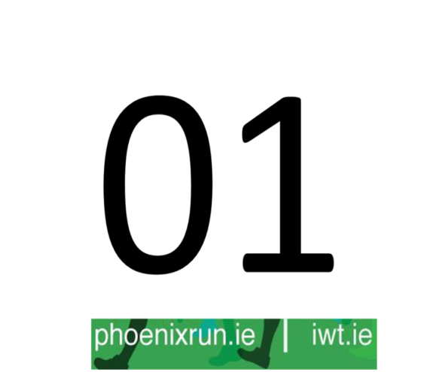

***Donation-***

As a working group, we decided to organise this charity run in aid of the Irish Wildlife Trust. We have contacted the chairperson of the IWT (Dr Daniel Buckley) and he is happy to be present at the end of the run to accept a ‘large cheque’ (ordered from Bank of Ireland).

***Entry fee-***

We decided on an early bird registration fee of €10 which can be purchased until the 19th of April, a fee of €15 will apply after this date. This fee is quite reasonable and is consistent with similar race fees.

***Route-***

Using mapmyrun.com we designed a 10km route for the event, around the Phoenix Park (see below).

